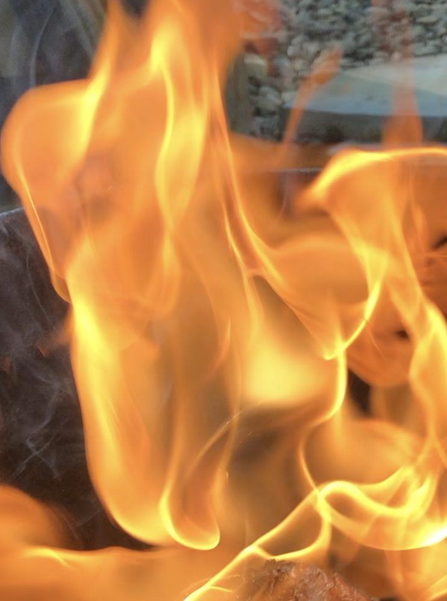
SMOKE – FUMED - SAGGAR – RAKU
1 DAY OF EXPLORATION

*****DATE***** 8:30 am – 5pm Location: My Simsbury, CT Studio
Participants, (max of 7) Fee - $300 per person 6-12 pieces per person.

This workshop will consist of Smoke, Fumed, Saggar and Raku firing techniques. Participants will work with basic and advanced techniques in a hands-on workshop designed to help develop skills in the application and firing processes I use. Thorough and detailed instruction will be provided. All aspects of materials, application, and firing techniques will be covered and all necessary materials will be provided except those listed for you to bring below.

Day before XXX pm********* Meet and greet over Pizza, drop off and unpack work *****************
Workshop Day 8:30 - 9:00 am – continue to unpack and intro for participants that did not make the evening before. 9:00 - 9:20 go over all the workshop processes that will be covered.
Firings 1st Firing, Smoke – We will be using feathers, hair, pine-needles, foil smoke saggar etc... For this firing, pieces can be stacked up so you can fire 1- 4 pieces each. 2nd Firing, Smoke + Ghost Feathers, leaves, shapes…on colored pieces. 1- 2 pieces each.
12/12:30 - Lunch
3rd Firing, Fuming. 1 piece each. 4th Firing, Slip Saggar firing 1 piece each. 5th. Raku using glazes (crackle and coppers + gold luster). (2-4 pieces)
Last Kiln will be loaded at 4:00
6th firing - TIME PERMITING - we will use the remaining time for exploring type of firing time permits.

What to bring:
The work: I have 2 Raku kilns and we can fit up to 4-6 kiln firings in a day, but it does depend on the group. That represents a potential total of 6 - 12 pieces per person for the workshop.
Pieces need to be kept to 15” in height or lower and 6” wide in-order to fire the estimated numbers.
***Bring your pieces made of stoneware, porcelain, or raku cone 10 clay bodies bisque fired to cone 06/05 (lower gets better blacks). Dark and light clay bodies do make a difference so bring both if you can. If possible, bring burnished vessels for the smoke firings using hair, feathers, hay and pine needles. These Burnished vessels are also great for the saggar firings. If you prepare your pieces with Terra Sig, bring them. They also look beautiful but be sure to Bisque fire to a regular 06/05 if you want to use them for the saggar firings. Non burnished vessels do have a different look so it’s good to try them as well.
Preferred forms are wheel thrown vases with consistent wall thickness. Hand-built sculpture, open forms and flat forms work to but do have a harder time surviving the thermal shock. That has never prevented us from using hand-built forms with these finishes, we just expect a higher loss.

What to bring for the Smoke firing:
Bring your hair, horsehair and feathers. I will have sugar, pine needles and other materials to use.
What to bring for the Fuming firing:
I have everything.
What to bring for the Saggar firing:
I will provide all the materials needed. Bring Newspaper for the reduction if you have it.
What to bring for the Raku firing:
I will provide all the materials needed. You are welcomed to bring your own glaze/glazes.
Bring Glossy Magazines if you can. We normally use one magazine for every piece.

Propper Attire:
It is important to wear protective clothing such as jeans, long-sleeve cotton shirt and shoes/boots that cover your feet well. Leather is recommended, stay away from synthetic material. I have the jackets and eye protection but if you have your own, you are welcomed to bring it.

Food
Take out lunches can be ordered from several nearby restaurants. Local-Restaurants

Lodging
If you want to stay in the area, here are some local places: Lodging

My Studio is at:
10 Crescent Way, Simsbury, Ct 06070
For questions: (c) 860-985-1389 Email garciav@ccsu.edu

