
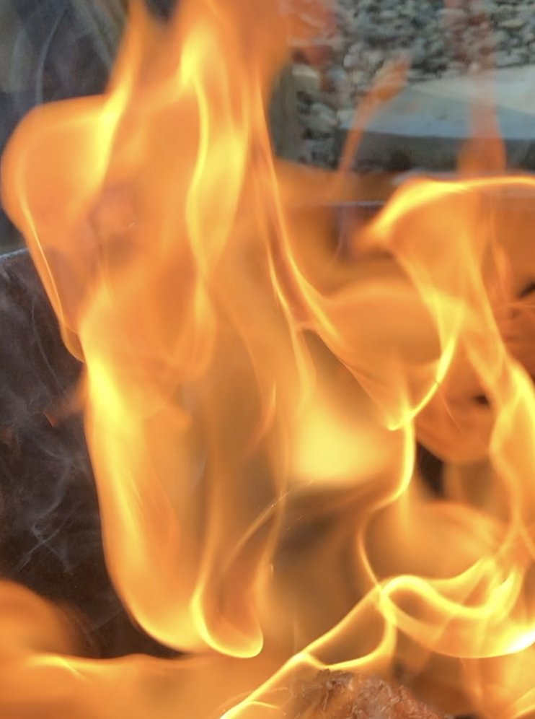
The Raku Experience
SMOKE, OBVARA, SAGGAR & RAKU
WITH @VICENTEGARCIAART

Location: Studio Garcia, Simsbury CT.
Pieces per student – (10-15 students 5 pieces each) - (16- 25 students 3 pieces each)

This workshop will consist of Smoke and Raku firing techniques. Participants will work with basic and advanced techniques in a hands-on workshop designed to help develop skills in the application and firing processes I use. Thorough and detailed instruction will be provided. All aspects of materials, application, and firing techniques will be covered and all necessary materials will be provided except items below.
Firings
1st & 2nd Obvara & Smoke firing using feathers, hair, pine-needles etc. (1 or 2 pieces)
2nd Saggar Fired vessel (1 Piece)
3rd. Raku (crackle and coppers + gold luster). (1 or 2 pieces)

****these numbers are based on pieces being a maximum of 4” wide and max of 10” tall****

What to bring:
The work: - Bring your pieces made of stoneware, porcelain, or raku cone 10 clay bodies bisque fired to cone 06/05 (lower gets better blacks). Dark and light clay bodies do make a difference so bring both if you can. Burnished vessels for the smoke firing using hair, feathers, hay and pine needles. These Burnished vessels are also great for the saggar firings. If you prepare your pieces with Tarra Sig bring them. They also look beautiful! Non burnished vessels do have a different look so it’s good to try them as well.
Preferred forms are wheel thrown vases with consistent wall thickness. Hand-built sculpture, open forms and flat forms have a harder time surviving the thermal shock but that has never prevented us from exploring these finishes, we just expect a higher loss. Keep forms to less than 4” wide in-order to fire higher numbers.
All aspects of materials, application, and firing techniques will be covered and materials will be provided.
What to bring for the Smoke firing - Bring your hair, horsehair and feathers. I will have sugar, pine needles and other materials to use.
What to bring for Obvara firings - I have everything.
What to bring for the Saggar firing - I have everything. Bring Newspaper for the reduction if you have it.
What to bring for the Raku firing - I have everything. You are welcomed to bring your own glaze/glazes.
Bring Glossy Magazines if you can. We normally use one magazine for every piece.
Propper Attire:
It is important to wear protective clothing such as jeans, long-sleeve cotton shirt and shoes/boots that cover your feet well. Leather is recommended, stay away from synthetic material. I have the jackets and eye protection but if you have your own, you are welcomed to bring it.

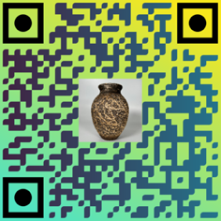
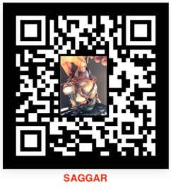
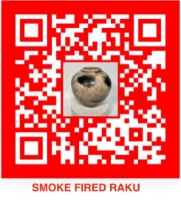
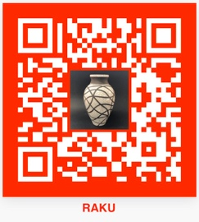
My studio is at:10 Crescent Way, Simsbury, Ct 06070 For questions: Email garciav@ccsu.edu
OBVARA

