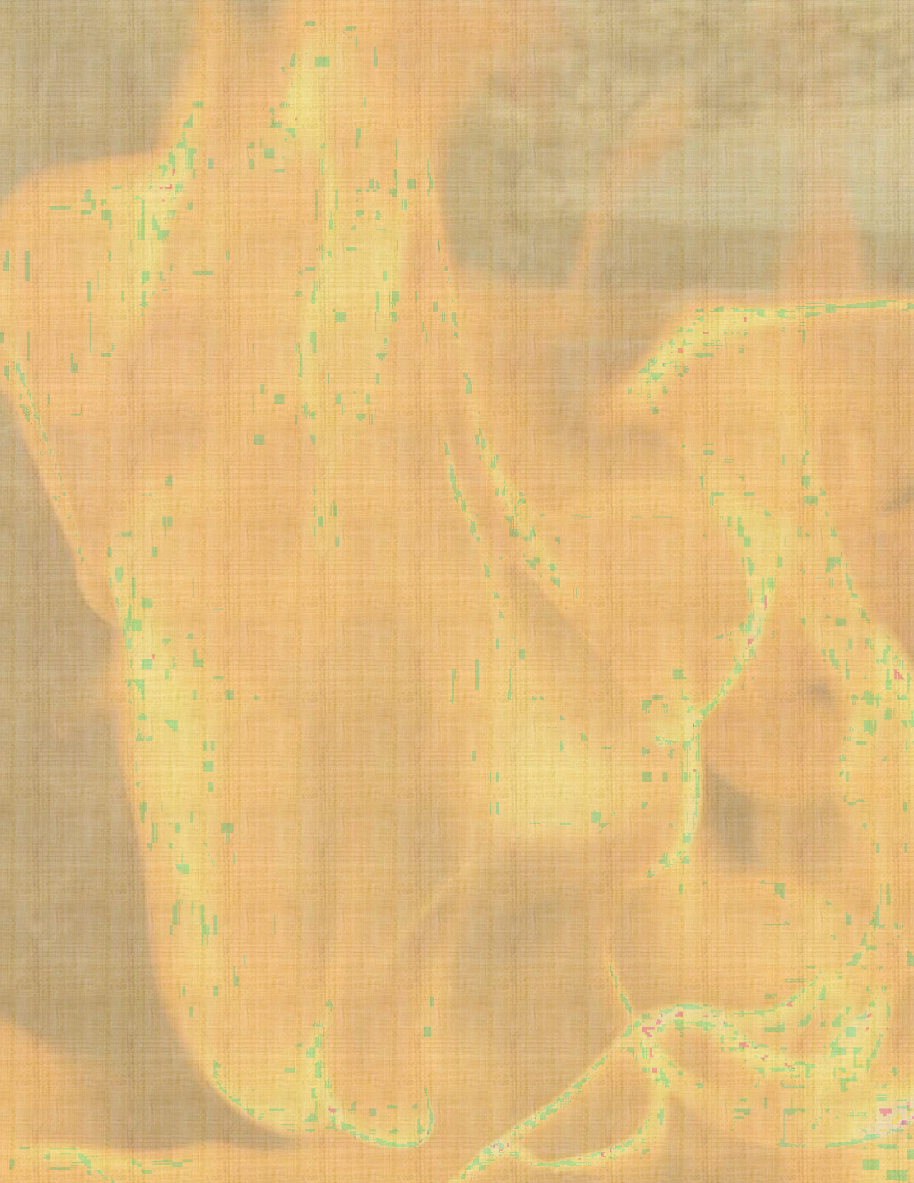
The Alternative Firing Experience:
Smoke - Obvara - Fumed - Saggar - Raku
A 3-DAY WORKSHOP
WITH - VICENTE GARCIA

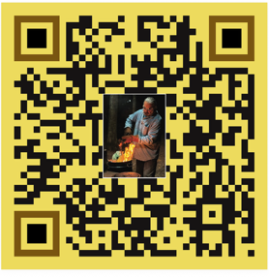

*****Date*****
Max Participants, 7 Fee - $975 per person Bring 20-47 bisque fired pieces

Location: My Simsbury, CT Studio 10 Crescent Way, Simsbury, CT 06070
My cell is 860-985-1389, feel free to call with questions.

THE DETAILS:
This workshop will consist of Smoke, Obvara, Fumed, Saggar and Raku firing techniques. Participants will work with basic and advanced techniques in a hands-on workshop designed to help develop skills in the application and firing processes I use. Thorough and detailed instruction will be provided. All aspects of materials, application, and firing techniques will be covered, and all necessary materials will be provided except those listed for you to bring below. The 3 days will allow for thorough immersion in each individual process and allow for at least one day to discuss, trouble shoot, re-fire and refine your technique.

Thursday before workshop 6:00 pm** Meet & Greet over Pizza, unpack work & Go Over Workshop Processes**
Friday 7 – 18 Pieces Each 8:30 - 9:00 am – continue to unpack and intro for participants that did not make the evening before. 9:00 - 9:15 go over all the workshop processes for the Day.
1st & 2nd Firing, Smoke & Obvara - We will be using feathers, hair, pine-needles, foil smoke saggar etc... For these firings, pieces can be stacked up so you can fire 2 - 6 pieces each.
3rd Firing, Smoke + Ghost Feathers, leaves, shapes…on colored pieces. Up to 2 - 6 pieces each. We will be using washes for a gas/raku and an overnight electric firing for smoke firing on Saturday. 1 - 3 for (Friday Smoke) 1 - 3 for Saturday
12/12:30 - Lunch
4th Firing, Fuming. 1-2 piece each. 5th Firing, Slip Saggar firing 1-2 piece each. If time permits, we will fire a 6th Firing or prepare pieces for Sunday morning 1-2 pieces.
Saturday 6 -12 including the 1 - 3 from the Friday electric kiln firing. 1st & 2nd Firing, Fire 1-3 pieces prepared Saturday for the Electric fired colored pieces using Ghost feathers, images…. + 1- 4 additional pieces for the hair, pine-needles, foil smoke saggar obvara etc...
3rd Firing Slab Saggar 1 - 2 piece.
12/12:30 – Lunch 4th Firing Raku firing process. 2 - 3 pieces each. 5th Firing Raku firing process. 2 - 3 pieces each Last kiln load will be loaded at 3:30 pm.

Late Saturday, discuss/troubleshoot work produced and decide on the firing schedule for Sunday.
Sunday 7 - 17 pieces. Explore the firing processes as decided by group. Last kiln load will be loaded at 3:00

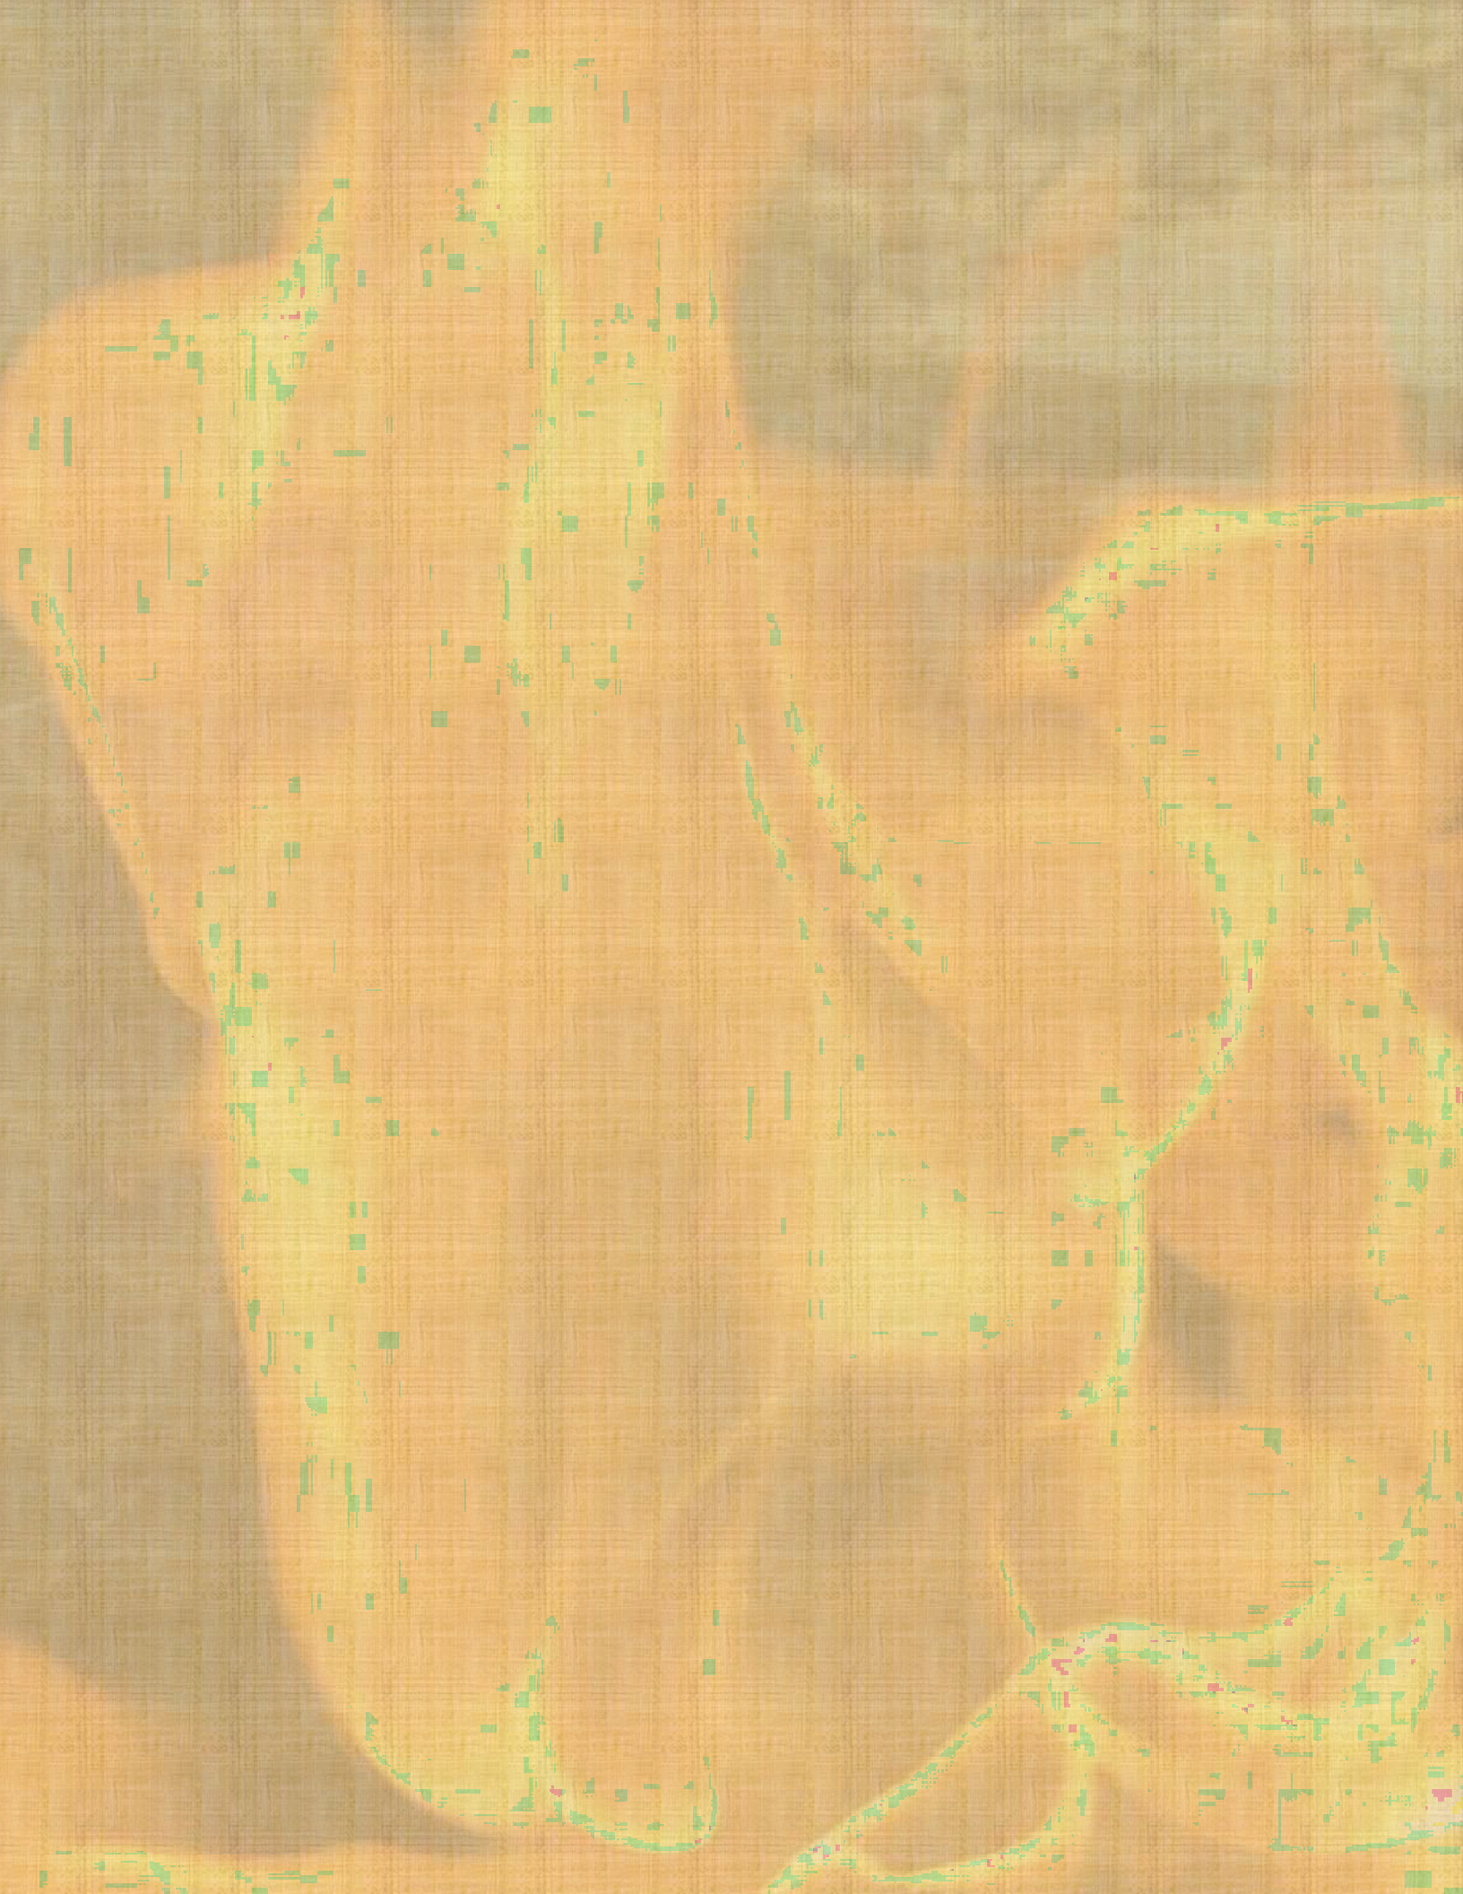
What to bring:
The work: I have 2 Raku kilns, and we can fit up to 5 kiln firings in a day. That represent about 20-47 pieces person. Pieces need to be kept to 15” in height or lower and 6” wide (PLEASE RESPECT THIS) in-order to fire the estimated numbers. 15 pieces will allow you to have the minimum amount in every firing. I say work on bringing 47 pieces, “better to take unfired pieces home than not have enough”.

***Bring or ship pieces made of stoneware, porcelain, or raku cone 10 clay bodies bisque fired to cone 06/05 (lower gets better blacks). Dark and light clay bodies do make a difference so bring both if you can. If possible, bring burnished vessels for the smoke firings using hair, feathers, hay and pine needles. These Burnished vessels are also great for the saggar firings. If you prepare your pieces with Terra Sig, bring them. They also look beautiful but be sure to Bisque fire to a regular 06/05 if you want to use them for the saggar firings. Non-burnished vessels do have a different look so it’s good to try them as well.
Preferred forms are wheel thrown vases with consistent wall thickness. Hand-built sculpture, open forms and flat forms work to but have a harder time surviving the thermal shock. That has never prevented us from using hand-built forms with these finishes, we just expect a higher loss. (be sure to keep flat and open forms to 6” or less in width)
What to bring for the Smoke firing:
Bring your hair, horsehair and feathers. I will have sugar, pine needles and other materials to use.
What to bring for the Fuming firing and Obvara firings:
I have everything.
What to bring for the Saggar firing:
I will provide all the materials needed. Bring Newspaper for the reduction if you have it.
What to bring for the Raku firing:
I will provide all the materials needed. You are welcomed to bring your own glaze/glazes.
Bring Glossy Magazines if you can. We normally use one magazine for every piece.

Propper Attire:
It is important to wear protective clothing such as jeans, long-sleeve cotton shirt and shoes/boots that cover your feet well. Leather is recommended, NO synthetic material. I have the jackets and eye protection but if you have your own, you are welcomed to bring it. We work outside but if you like a respirator, bring it.

Food:
Take out lunches can be ordered from several nearby restaurants. Local/Restaurants
Lodging:
If you want to stay in the area, here are some local places: Local/Lodging
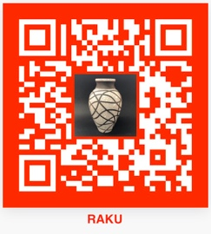
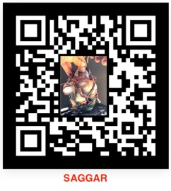


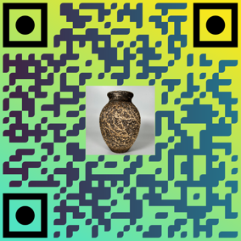

OBVARA

